The University of Azad Jammu and Kashmir, Muzaffarabad
Name | Danial Ayub Mughal
Roll Number | 2024-SE-20
Class | 4rd Semester
Subject | Computer Networks (Lab task 06)
Course Code | CS-2203
Submitted To | Engr. Dr .Asma Javaid


Department of Software Engineering

Star Topology Using Switch

Introduction:
A star topology is a network configuration in which all devices (computers, printers, etc.) are connected to a central device called a switch. The switch manages communication between devices, making the network efficient, reliable, and easy to troubleshoot.

To design and configure a star topology using a switch and assign IP addresses to ensure communication between devices.

Procedure

Step 1: Open Simulation Software
Open Cisco Packet Tracer and prepare a blank workspace for network design.
Step 2: Add Devices (Star Layout)
Place one switch at the center and add multiple PCs around it to form a star topology.
Step 3: Connect Devices to Switch
Connect each PC to the switch using straight-through cables (all links should turn green)
Step 4: Configure IP Addresses
Assign unique IP addresses to each PC within the same network (e.g., 192.168.1.x with subnet mask 255.255.255.0)
Verify Connectivity Using Ping and Packet Simulation
Use the ping command between PCs and also test using simulation mode to observe packet flow through the switch.

Step 1 & 2: Adding Switch and PCs (Star Layout)
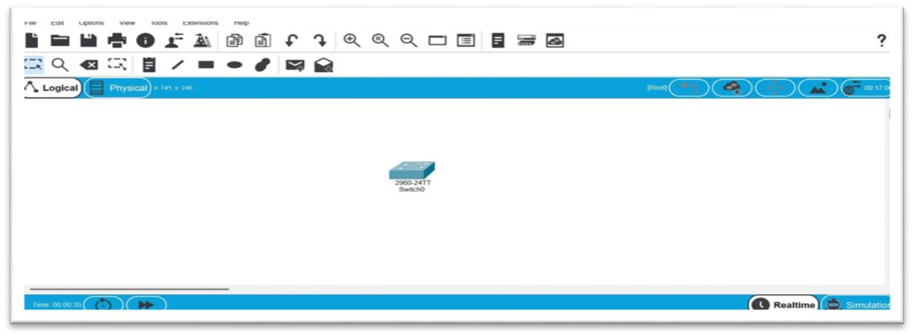
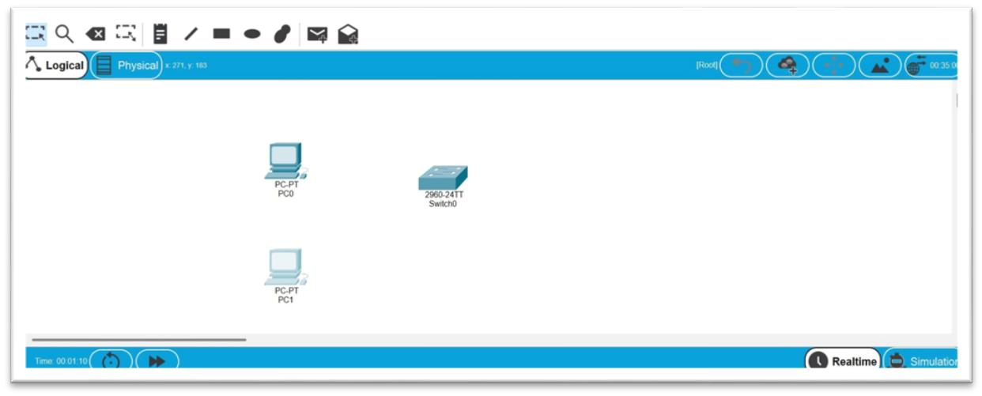

Step 3: Connecting Devices to Switch
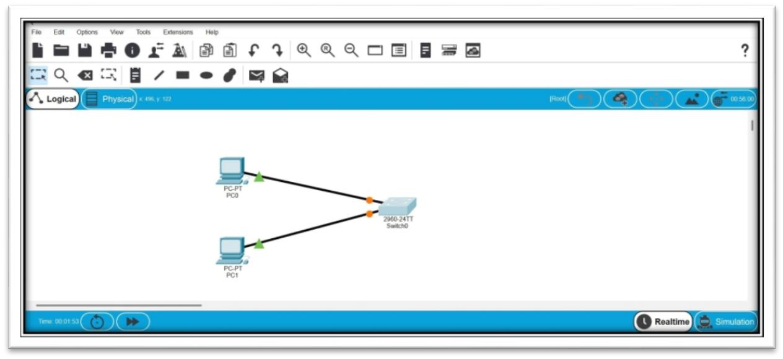

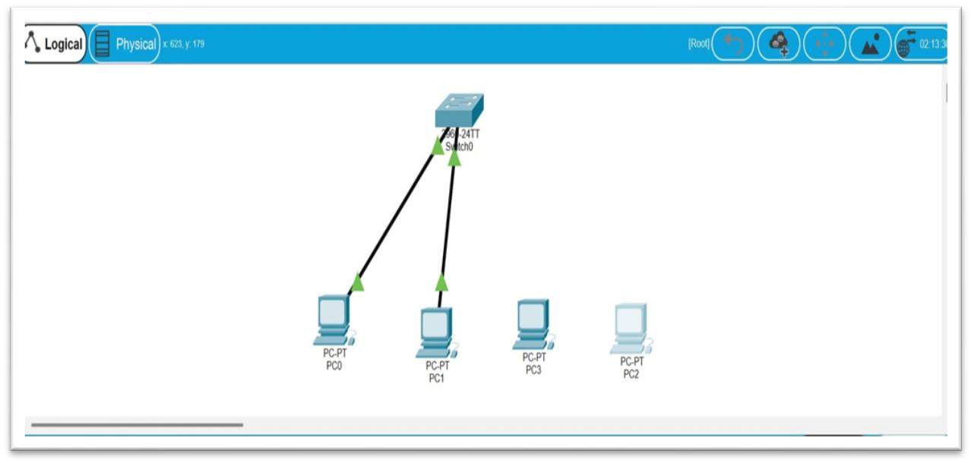

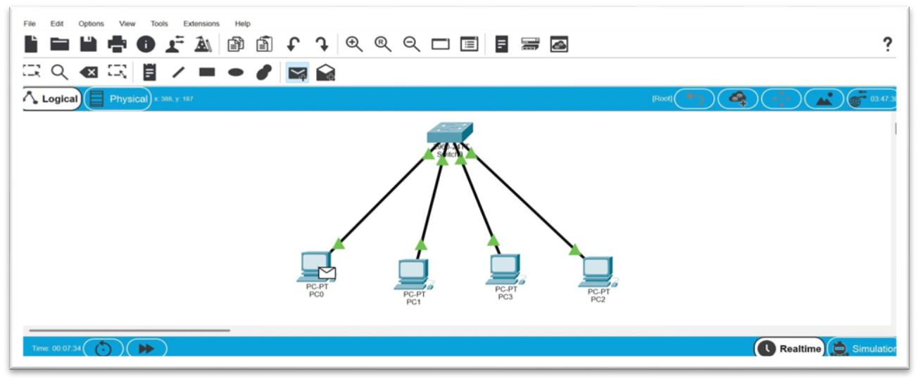
Step 4: Configuring IP Addresses (Multiple PCs)
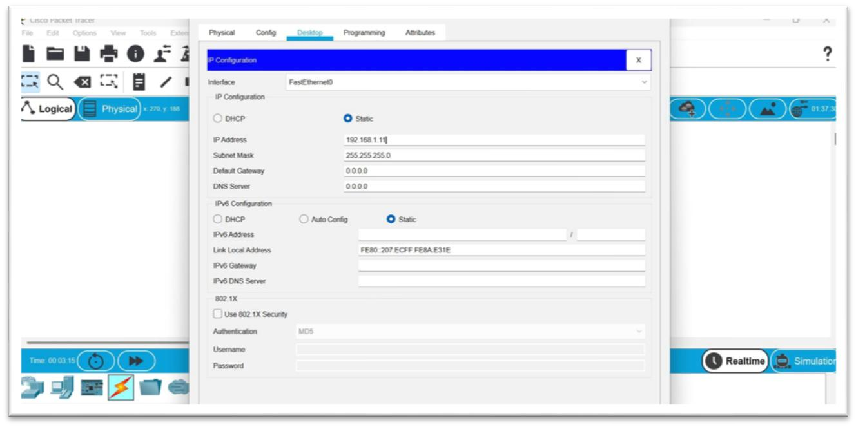

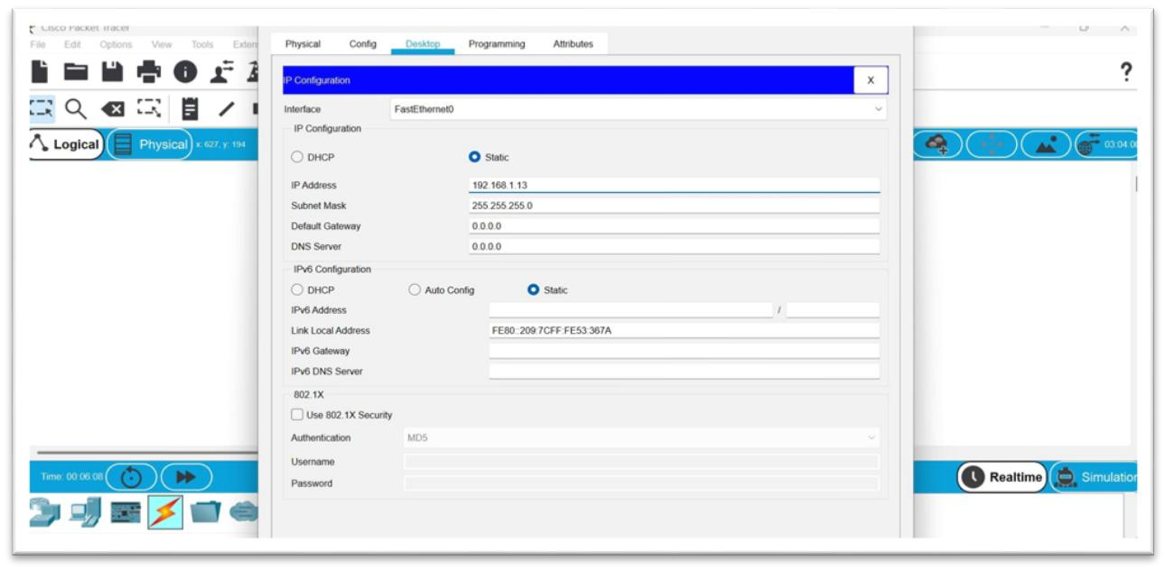

Step 5: Ping Results and Packet Simulation
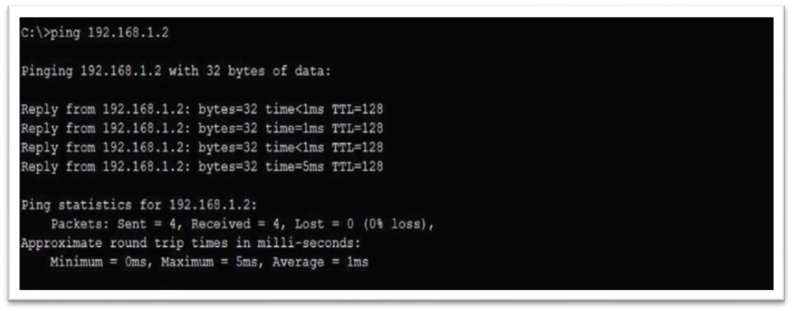

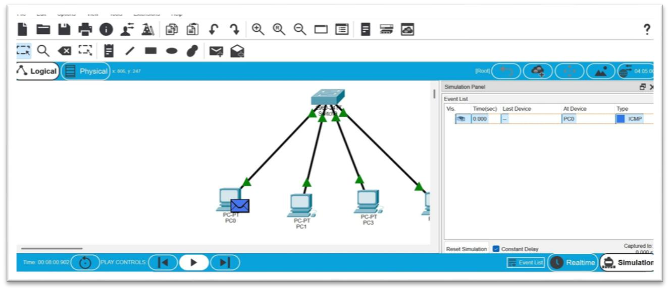

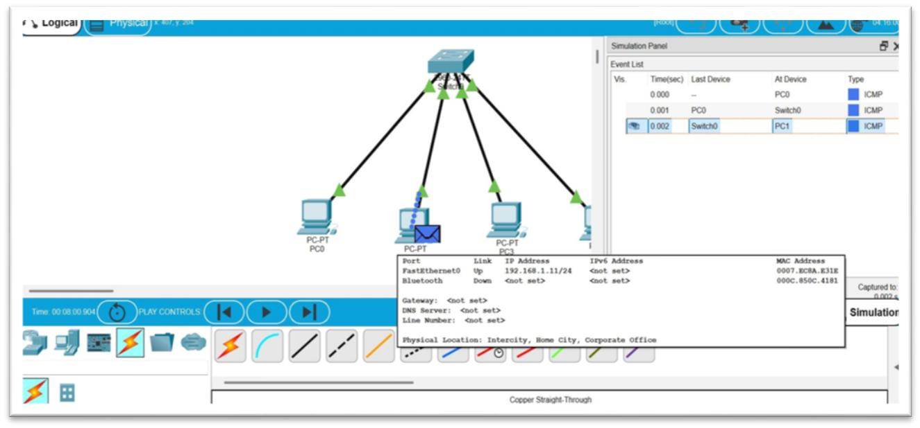
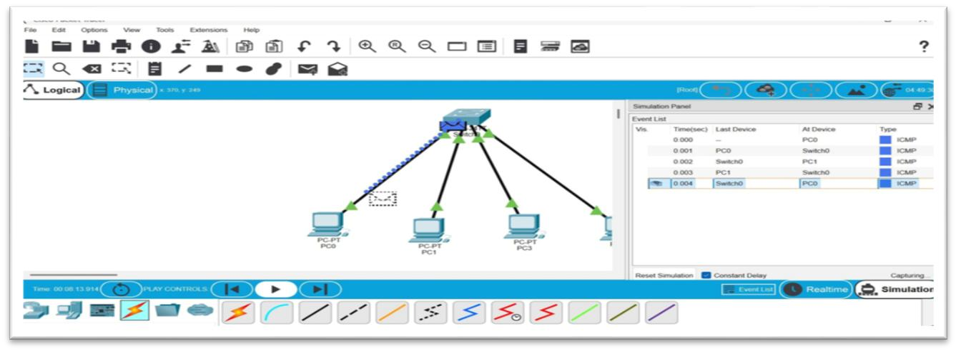

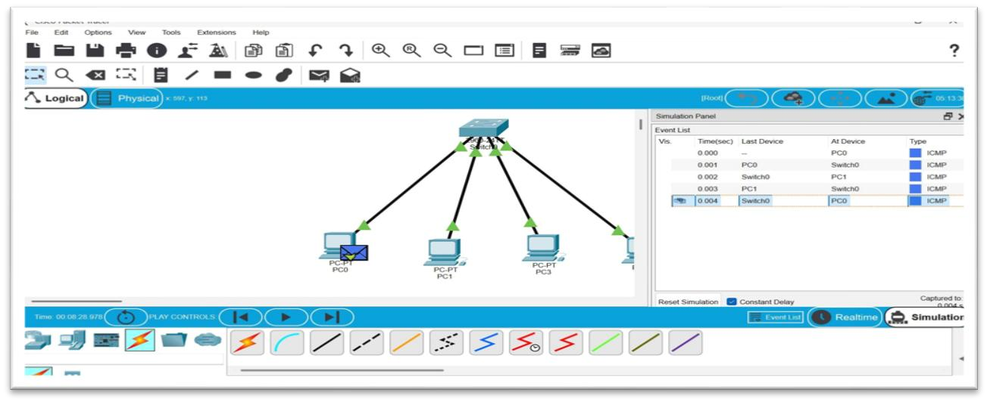

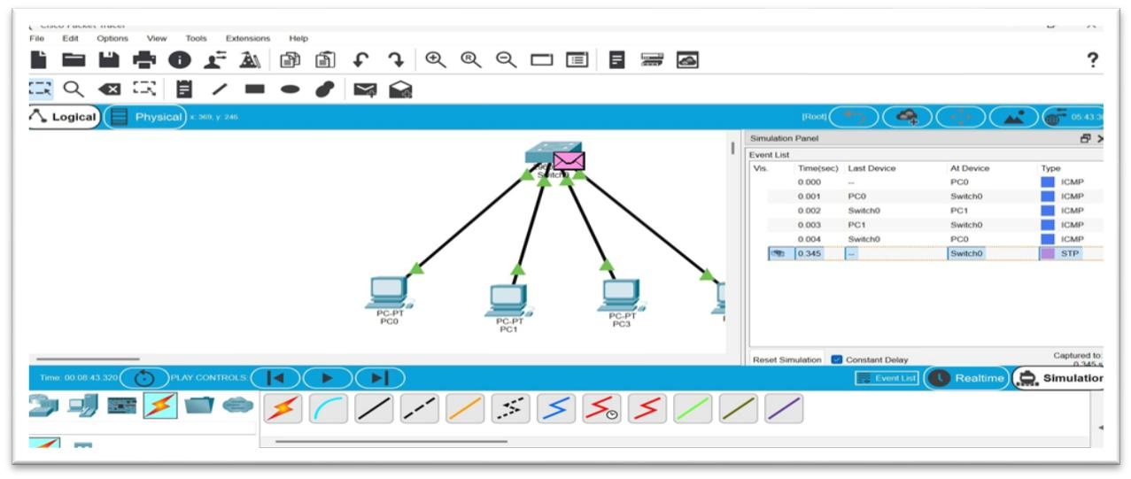

Conclusion
The star topology using a switch provides efficient communication and centralized control. It is easy to manage and troubleshoot, making it one of the most commonly used network topologies.

